Testing and Documentation

Example Template for Testing

Candidate Name: Lauren Smart Candidate ID: 19016480
Software Development: Object Oriented Programming Project: Olympics
Acceptance Test Table Date of test: 22/03/2021
Test Case 1: Manual Testing
Test Case | Reason for Test | Test Item | Expected Result | Actual Result
1.1 | Test default constructor and setters for Competitor | 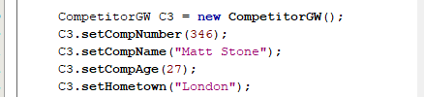 | A competitor object created | Pass Test  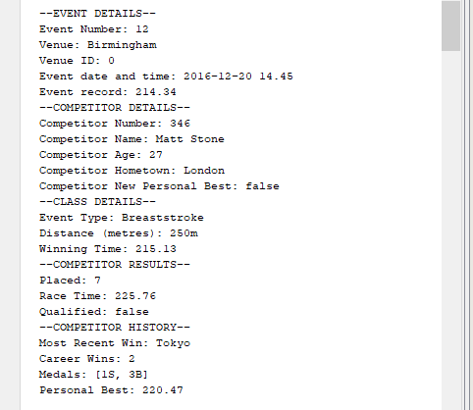
1.2 | Test toString() method and getters for Competitor |  | Competitor details displayed | Pass  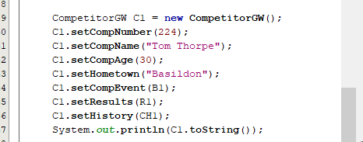
1.3 | Create a Breaststroke object | 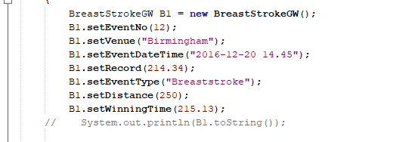 | Breaststroke (extends Event class) object created | Pass test  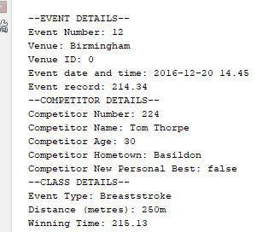
1.4 | Test Breaststroke class constructor with parameters passed in | 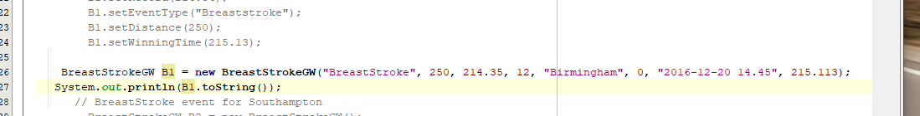 | A breaststroke object created with the same output as class object above | Pass Test  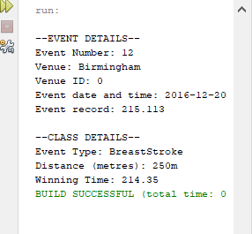
1.5 | Competition object instance |  | A competition object created | 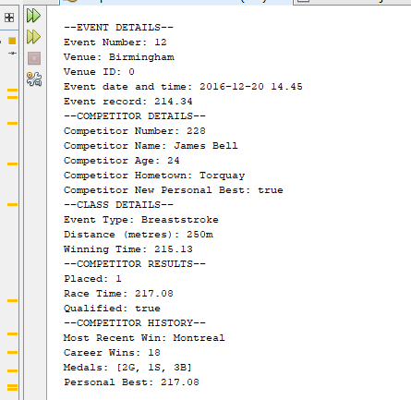  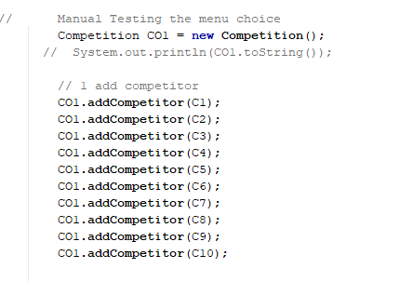  Passed
1.6 | Result object | 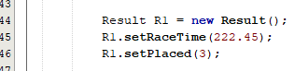 | A result object created | Pass test  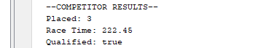
1.7 | Competitor History object |  | A competitor history object created | 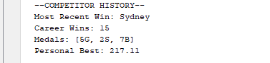  Passed  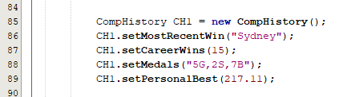
2 | CO1.addCompetitor(C1); | 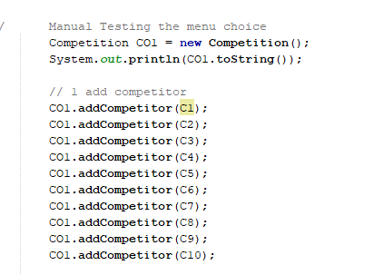 | The competitor is added to the competition. | 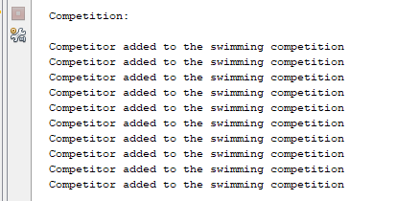  Passed test
3 | CO1.deleteCompetitor(C1); |  | Delete a competitor from competition
 | CO1.clearAll(); |  | Clears the competition from competition.
 | CO1.saveToFile(); | 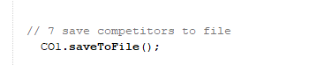 | A text file created with the competitors' details | Passed
 | CO1.getAllByEvent(12); |  | Returns the competitors from the selected event 12 (the parameter will contain the event number) | 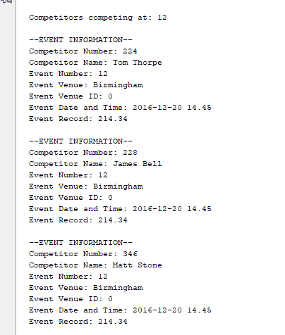  Passed
 | CO1.getAllByEvent(15); | 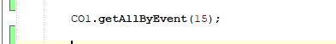 | Returns the competitors from the selected event 15 (the parameter will contain the event number) | 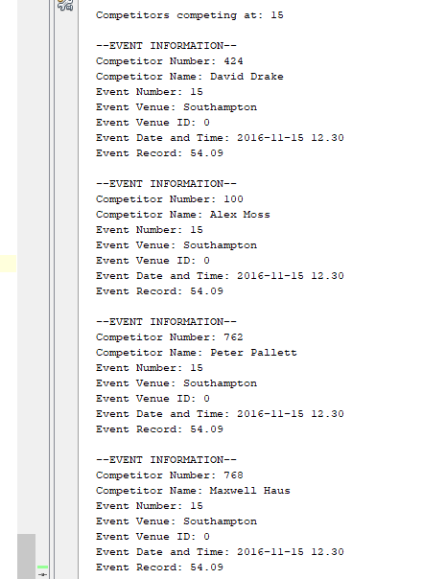  passed
 | CO1.getAllByEvent(17); | 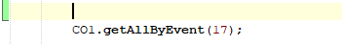 | Returns the competitors from the selected event 17 (the parameter will contain the event number) | 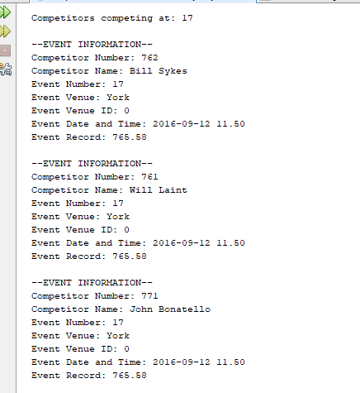  Passed
 | CO1.loadFromFile(); | 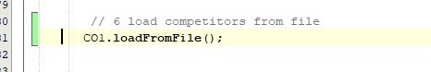 | Loads the competitors to file | 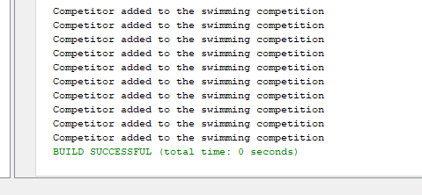
 | CO1.saveToFile(); | 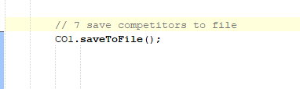 | Saves the competition to file | 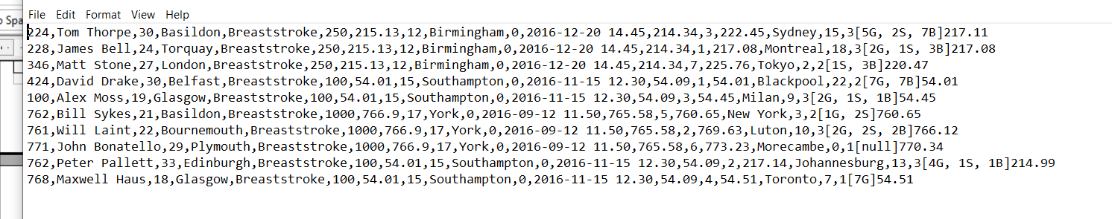  Passed
 | CO1.getCompIndex(); | 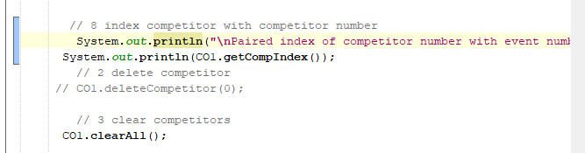 | Returns a paired index of competitor number with compEvent | 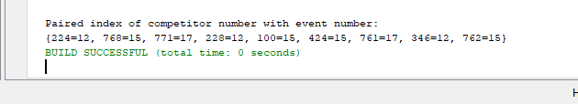
 | CO1.sortCompetitorsByAge(); |  | Return the competitor's sorted by ascending age | 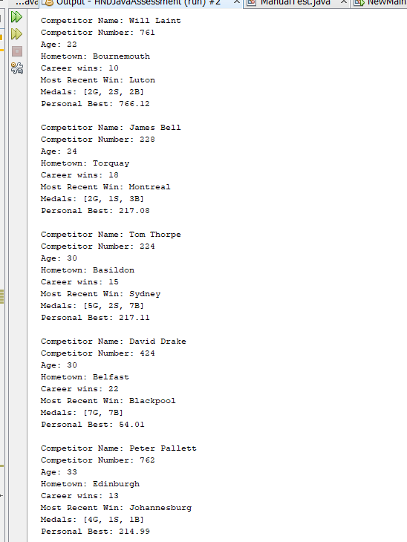
 | CO1.winners(10); | 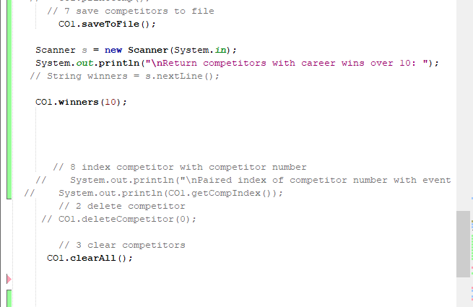 | Returns the competitors with wins over 10 | Passed  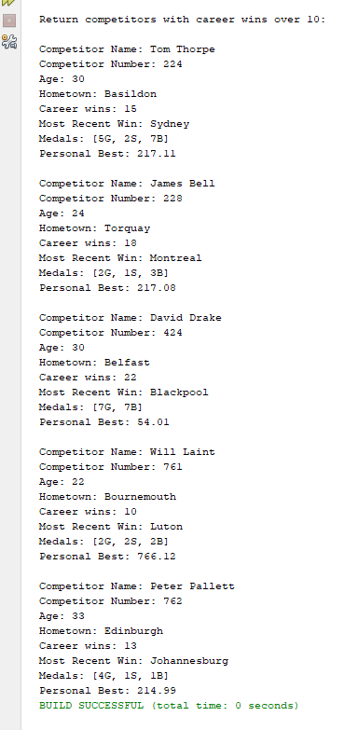
 | CO1.getQualifiers(); | 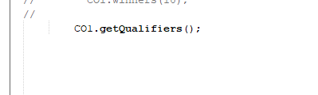 | Returns the qualifying competitors | Passed test  